SharePoint

GOVERNANCE

PLAN

Company: | SharePoint Maven, Inc.
Author: | Gregory Zelfond
Email: | greg@sharepointmaven.com
Website: | sharepointmaven.com
Version: | 1
Revised: | May 8, 2019

Notes on this Governance Template
FINE PRINT (AKA THE GROUND RULES FOR USING THIS TEMPLATE)
- This Governance Plan Template is made available to you courtesy of SharePoint Maven, Inc.
- You may use this template as you wish within your respective organization free of charge.
- You may not sell this template to anyone or make a profit off it.
- You may not post this template in its original or in a revised form on any public websites.
HOW TO UPDATE THIS TEMPLATE
Your company name, which is referenced throughout this document can easily be updated by updating the MS Word document property. Here are the steps:
- Update the My Business Name property from SharePoint Maven, Inc. to your company’s name as shown in the screenshot below.
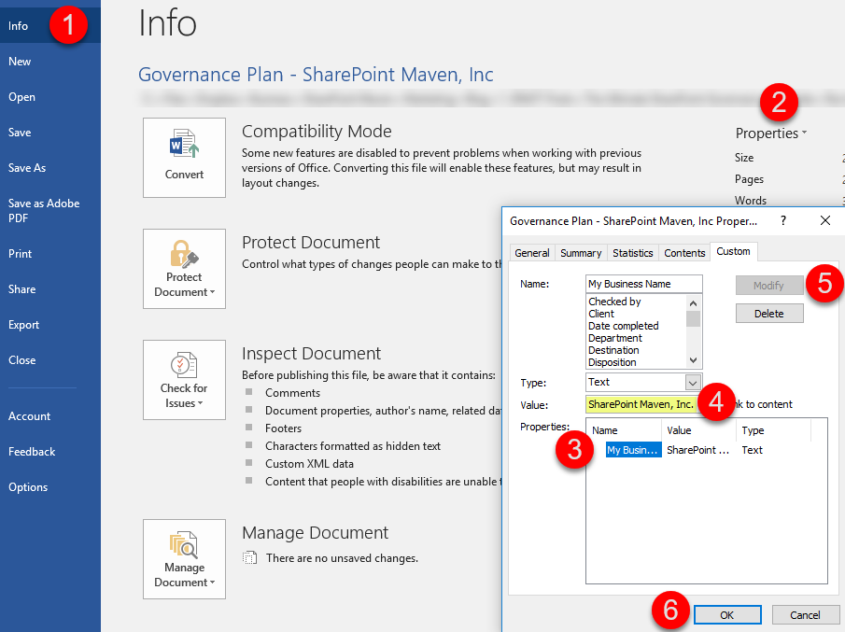
- Press CTRL-A to select all of the content in the document.
- Select the Update entire table radio button, then press OK.
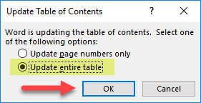
- Your company name will be updated throughout the entire document.
LINKS
- Where applicable, the document references articles on SharePoint Maven blog for an in-context explanation of key concepts, features and best practices.
- The document uses automatic header and section numbering as well as cross-reference hyperlinks for easy navigation within a document.
Table of Contents
Notes on this Governance Template 2
1. Overview 5
1.1. Document Objective 5
1.2. Revision History 5
1.3. Related Documents 5
1.4. About SharePoint Maven, Inc. 5
2. Site Architecture 6
2.1. Types of Sites 6
2.2. Site Collections 6
2.3. Use of Subsites in Site Collections 6
2.4. Office 365 Group Sites 7
2.5. Hub Sites 7
3. Security 8
3.1. Roles 8
3.2. Three-Group Security Model 9
3.3. Company-Wide Security Groups 9
3.4. Custom Permission Levels 9
3.5. # of Site Collection Admins 10
3.6. Sharing/Access Request Settings 10
3.7. Subsite Security Inheritance 10
3.8. Folder and File Level Security 10
3.9. External Sharing 11
4. Navigation 12
4.1. Three Types of Navigation 12
4.2. Hub Navigation 12
4.3. Site Collection Navigation 12
4.4. Quick Launch Navigation 12
5. Look & Feel 13
5.1. Site Templates 13
5.2. Logo 13
5.3. Site Colors 13
5.4. Custom Branding 14
5.5. Page Templates 14
6. Taxonomy & Metadata 15
6.1. Two Types of Metadata 15
6.2. Term Store Metadata 15
6.3. Term Store Access 16
6.4. Content Types 16
6.5. Use OF Folders and Metadata 16
7. Retention and Deletion 17
7.1. Content Retention Policy 17
7.2. Site Retention PolicY 17
8. 3rd Party Tools and Integrations 18
8.1. Out of the Box Philosophy 18
9. OneDrive for Business 19
10. Training & Onboarding 20
10.1. Employee Training Requirements 20
10.2. Employee Training Deadlines 20
11. Help Desk 21
11.1. SharePoint Requests 21
11.2. SharePoint Support 21

Overview

Document Objective
The main objective of this document is to set the minimum rules of engagement, policies and guidelines related to the use and administration of the SharePoint Maven, Inc. SharePoint Online Environment.

Revision History
Revision | Date | Description | Revised By
1 | May 8, 2019 | Draft Governance Plan | Greg Zelfond

Related Documents
Document Name | Revision | Author
N/A | N/A | N/A

About SharePoint Maven, Inc.
SharePoint Maven, Inc. is a one-person SharePoint consulting firm that specializes in helping small- to mid-sized businesses migrate to SharePoint and Office 365 using SharePoint’s out-of-the-box functionality.
Greg Zelfond, SharePoint Maven’s founder, uses his 10 plus years’ experience as a SharePoint Consultant and technology project manager to develop sites that facilitate team collaboration, simplify project management and streamline document management.

Site Architecture

Types of Sites
The SharePoint Environment at SharePoint Maven, Inc. consists of the following types of sites:
- Employee Facing Sites
- Department Team Sites
- Project Sites
- Client Sites
Employee Facing Sites are sites that are accessible by the whole (or a majority of the) company. Examples include Intranet Landing Page Sites and HR Employee Sites. Typically, the content for Employee Sites will be available on a read-only basis for everyone in the whole company, except for those few employees who maintain the content on those sites.
Department Team Sites are sites that are only accessible by those who are part of the department/division/team. Examples include HR Team Site, Leadership Team Site, and Sales Team Sites.
Project Sites are sites that employ project management components. They are based on a specific site template that has been customized to meet company requirements with project specific folder hierarchies and metadata. These sites are linked to Office 365 Groups to take advantage of the built-in collaboration component.
Client Sites are sites that are shared with external clients or vendors. They generally contain content and elements that are specific to the individual client or vendor.

Site Collections
SharePoint Maven, Inc. has adopted a Flat Architecture model. What that means is that each type of site described in Section 2.1 is provisioned as a separate site collection rather than a subsite. This model allows for more flexibility in terms of site organization and external sharing.

Use of Subsites in Site Collections
Subsites are allowed in this SharePoint Environment and can be created by Site Owners at their discretion in any site they own, under the following conditions:
- Subsites are not allowed on any Employee Facing Site Collections as defined in Section 2.1. This prevents the accidental oversharing of information often associated with subsite security inheritance (see Section 3)
- Only 1 level of subsites is allowed in any site collection. This prevents the sprawl of multiple levels of subsites and reduces the risk of security and governance issues.

Office 365 Group Sites
Office 365 Groups Sites are sites that are connected to Office 365 Security groups and other Office 365 applications such as Outlook, Planner, and Teams. The use of Office 365 Group Sites is encouraged as the preferred type of site template (See Section 5.1) as long as they conform to the following conditions:
- Office 365 Group Site creation has to follow the process outlined in Section 11.1.
- A minimum of two (2) members are required in each Office 365 Group Site.
- Office 365 Group Sites cannot be used for Employee Facing Sites as defined in Section 2.1 since Employee Facing Sites require read-only access for the whole company.

Hub Sites
Hub Sites provide the means to organize and combine separate site collections (Office 365 Group Sites, Communication Sites, and other site collections) into logical groupings. Site Collections that are part of a Hub Site share the following common attributes:
- Common navigation (see Section 4.2)
- Common Theme/Colors (see Section 5.3)
- Unified Search
- Roll-up of News and Events
The following Hub Sites have currently been defined and created in SharePoint Maven, Inc.’s SharePoint environment:
Hub Name | Purpose
Intranet Hub | Links all Employee-facing department sites
Project Hub | Links all Project Sites
HR Hub | Links HR Employee-facing sites as well as HR Team Sites

Hubs can be used and created by any department under the following conditions:
- Hub Site registration must follow the process outlined in Section 11.1
- Site Collections can be connected (associated) or disconnected from a Hub Site only by the Hub Owner (see Section 4.2)

Security

Roles
Though SharePoint and Office 365 have their own pre-defined security roles, below is a list of Security Roles defined by the SharePoint Maven, Inc. Governance Committee:
Role Name | Authority
Office 365 Global Administrator | - Has admin access to Office 365 Admin Center and all the Office 365 Admin Centers (SharePoint, Exchange, OneDrive, and Azure AD)  - Has access to all the Site Collections and OneDrive Accounts
SharePoint Administrator | - Has admin access to SharePoint and OneDrive Admin Centers only  - Has access to all the Site Collections and OneDrive Accounts
Site Collection Administrator | - Has admin access to a given site collection only
Site  Owner | - Has admin access to a given site only  - In the context of Office 365 Groups or Communication Sites (see Section 2.2), Site Owner is the same as the Site Collection Administrator  - In the context of subsites (see Section 2.3), Site Owner is the owner (Administrator) of a given subsite
Hub Owner | - Has the ability to associate a site collection to an existing Hub  - Usually the same individual as the SharePoint or Office 365 Administrator or a Site Collection Administrator of a Parent Hub Site (see Section 4.2)
Term Store Administrator | - Has Admin access to the Term Store (see Section 6.2)
Term Store Group Manager | - Has Admin Access to the Term Store Group for a specific department/division/project (see Section 6.2)  - Usually the same individual as the Site Collection Administrator for a given department
Content Owner | - An owner of content for a specific department/division/team/project  - Usually a department head or a project manager or a team member  - Content Owners are not the same as Site Owners, although they could be  - Content Owners do not need to be proficient in SharePoint
End User  (everyone else) | - All the employees of SharePoint Maven, Inc. who do not have any administrative roles or permissions as defined above  - Usually has Read-only or Add/Edit/Delete content permissions on a given site
External User | - Any user outside of the SharePoint Maven, Inc. domain  - Not an employee of SharePoint Maven, Inc.  - A user who does not have SharePoint Maven, Inc. Office 365 credentials  - Usually a vendor, client or any other external party

Three-Group Security Model
SharePoint Maven, Inc. has adopted an out-of-the-box security model for its SharePoint sites. The table below represents an overview and description of the various out-of-the-box security groups and permission levels.
Security Group | Permission Level | Authority
Site Owners | Full Control | Can add/edit/delete content, delete sites, and set up permissions for a given site
Site Members | Edit | Can add/edit/delete content on a site
Site Visitors | Read | Can only read and download content

Additional SharePoint security groups can be created at the discretion of a Site Owner or a Site Collection Administrator. However, this practice is discouraged and should be minimized as much as possible.

Company-Wide Security Groups
SharePoint Maven, Inc. can maintain Office 365 Security Groups (Azure Active Directory Groups) that aggregate multiple company departments and divisions. Site Owners and Site Collection Administrators must utilize these Security Groups (if they have been established) whenever they need to grant access to multiple users who are part of a department or division. Maintaining centralized Security Groups helps keep security clean as employees join or leave the organization.
The table below captures all the existing global security groups for SharePoint Maven, Inc.
Group Name | Description
All Employees | Contains all employees of the company
Human Resources | Contains all employees of the HR Department
Leadership | Includes the CEO, CFO and senior leadership
Sales | Includes all Sales and Marketing Department employees
Board | Includes all the board members

Custom Permission Levels
While custom permission levels can be created by Site Collection Administrators, their use shall be avoided as much as possible. Site Owners and Site Collection Administrators must first utilize the out-of-the-box permission levels that currently exist. Custom permission levels can only be created by Site Collection Administrators under the following conditions:
- Custom permission levels are not allowed on Employee Facing Sites
- Out-of-the-box permission levels cannot be altered. Any new permission levels must be separately created by a Site Collection Administrator.
- Any custom permission levels created must be brought to the attention of the Governance Committee, so they can be properly documented

# of Site Collection Admins
Each site collection shall have a minimum of one (1) and a maximum of three (3) site collection administrators.

Sharing/Access Request Settings
Each Site Collection Administrator and Site Owner must decide whether sharing is to be enabled on a given site. By default, all sites, files, and folders within SharePoint can easily be shared by Site Members and Site Visitors with users outside of their respective teams even when those users have not been added explicitly by the Site Owner. However, Site Owners can change that behavior via Access Request Settings under Site Permissions.
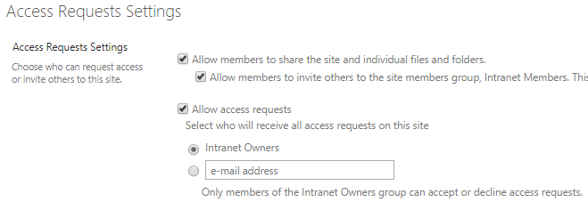
The following sites must have sharing disabled:
- Employee Facing Sites

Subsite Security Inheritance
If Site Collection Administrators allow the creation of subsites in their respective site collections, they must make Subsite Site Owners aware of the dangers of security inheritance. If possible, security inheritance must be broken between a subsite and a parent site collection.

Folder and File Level Security
When applicable, unique file and folder security can be set, however, the practice shall be avoided or minimized as much as possible. In those cases where certain files or folders must be hidden from a group of users, it is preferable to create a new Site Collection or a site with unique security.

External Sharing
External Sharing (sharing of content with users outside of SharePoint Maven, Inc.) is allowed and can be done under following conditions:
- External sharing must be requested via the Site Request process outlined in Section 11.1
- No anonymous sharing is ever allowed on any site collection within SharePoint Maven, Inc. (External users must be provided with authenticated login credentials to access and view any content.)
- External sharing is not allowed on Employee Facing sites (i.e. Intranet, HR Employee Site)
- File and folder sharing is preferred, while external sharing of sites shall be minimized

Navigation

Three Types of Navigation
SharePoint Maven, Inc. employs the following three types of navigation, all of which are available out-of-the-box in SharePoint. They are:
- Hub Navigation
- Site Collection Navigation
- Quick Launch Navigation

Hub Navigation
Hub Navigation is the umbrella navigation for all the site collections that are part of a given Hub. It is to be managed by the Hub Owner only.

Site Collection Navigation
Site Collection Navigation is the top navigation available on each site collection. It usually links the Site Collection with its subsites (if applicable) such as sites, links and pages. It is to be managed by the Site Collection Administrator only.

Quick Launch Navigation
Quick Launch Navigation (also called local navigation) is the navigation that appears on the left side of a Team Site or on the upper right-hand side of a Communication Site (see Section 5.1). Quick Launch Navigation shall link to content specific to a given site. It is to be managed by the Site Collection Administrator or the Site Owner.

Look & Feel

Site Templates
The following is a list of available site templates that have been approved by SharePoint Maven, Inc. SharePoint Governance Committee. The Site Template must be defined the when a new site is requested by the Site Owner using the process outlined in Section 11.1.
Template Name | Description | Purpose
Office 365 Group Team Site | Out of the box Team Site that comes with Office 365 Groups | - To be used for team collaboration.  - Cannot be used for Employee Facing sites
Communication Site | Out of the box Communication Site | - Must be used for Employee Facing sites
Project Site | Custom site template with project management web parts | - Must be used for all projects done as part of the company’s Project Management Office (PMO)

Logo
The following image is the only approved logo for all SharePoint sites. In case you would like to use a different logo on a site, you must obtain an approval from the Governance Committee.

Site Colors
The following color scheme has been officially approved by the SharePoint Maven, Inc. Marketing department as well as the Governance Committee. All Site Owners and Site Collection Administrators must customize the look and feel of their sites according to the colors defined below.

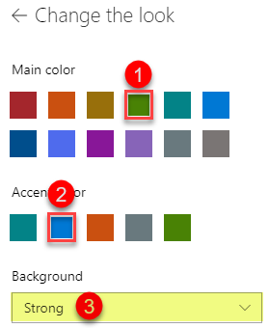

In addition, the following conditions apply and must be met:

- All the sites that are part of the Company Hub Sites identified in Section 2.5, must adhere to the colors and theme of the parent Hub. Changing or altering the colors or logos on the sites that are part of the Hub is not permitted.
- No altering of site colors is allowed on any Employee Facing sites, Project sites or Client Sites.
- Department Team Sites can have custom colors if necessary.

Custom Branding
As SharePoint Maven, Inc. employs only out-of-the-box functionality (see Section 8.1), no custom branding or custom themes are allowed within the company’s SharePoint environment.

Page Templates
SharePoint Maven, Inc. has switched exclusively to Modern SharePoint. As a result, no “Classic” (Wiki) pages are allowed. All the sites must be created using the Modern page layout.

Taxonomy & Metadata

Two Types of Metadata
SharePoint Maven, Inc. utilizes two types of metadata in its SharePoint Environment:
- Global Metadata
- Local Metadata
Global Metadata is metadata that is consistent and reusable among various site collections, lists and libraries. Examples include a list of SharePoint Maven, Inc. department names, client names, document types, and locations.
Local Metadata is metadata that is unique to a site, list or library and is not repeatable or reusable. Examples include project phases, status fields, etc.
All Global Metadata is to be defined in the Term Store (see Section 6.2).
All Local Metadata can be defined either in the Term Store or locally at the site/list/library level.

Term Store Metadata
Term Store is split into several different groups:
- Global Metadata
- Department-specific Metadata

The following is a list of existing (Global) Metadata/Term Sets that have been approved by the SharePoint Maven, Inc. Governance committee and are currently provisioned in the Term Store:
- Department Names
- Client Names
- Document Types
- Locations

The above-listed Term Sets are mandated by the Governance Committee. Site Owners must make every effort to utilize the above listed Term Sets in the following order:
- Use Term Sets as-is
- If the Term Set cannot be used as-is, a department-specific Term Set must be created, with a maximum number of terms being reused from the “Global” Term Set
- If the Term Sets are completely different, department-specific Term Sets can be created

Term Store Access
The following table shows the access levels to the Term Store:

Role Name | Authority
Office 365 Global Administrator | - Can Add/Edit/Delete any groups/term sets/terms, including Global Terms  - Can assign group permissions
SharePoint Administrator | - Can Add/Edit/Delete any groups/term sets/terms, including Global Terms  - Can assign group permissions
Site Collection Administrator | - Can Add/Edit/Delete department-specific term sets/terms  - Read-Only access to all other terms and term sets
Site  Owner | - Add/Edit/Delete access to the department-specific metadata at the discretion of a site collection administrator  - Read-Only access to all terms and term sets

Any changes to the access within Term Store must be requested via the Site Request process outlined in Section 11.1.

Content Types
SharePoint Maven, Inc. has standardized the following Content Types within its environment:
- Invoice Document
- Contract Document
- Project Document
The Content Types are available to all Site Collection and Site Owners via Content Type Publishing Hub and will appear under the grouping Custom SharePoint Maven, Inc. metadata.

Use OF Folders and Metadata
While it is up to Site Owners to decide whether to use either folders or metadata on their sites, folders are not allowed on the following types of sites:
- Employee Facing Sites
- Project Sites
These site types must use metadata to organize and group documents. This helps ensure that end users have a consistent experience.

Retention and Deletion

Content Retention Policy
SharePoint Maven, Inc. is utilizing the Security & Compliance Center within Office 365 environment for the retention and records management of content within our SharePoint environment. As such, the following retention and record management rules have been established:
- All content within the SharePoint environment is to be retained indefinitely, unless deleted by the users of the site
- SharePoint Maven, Inc. does not utilize any retention or disposition review policies of content. All content is to be retained indefinitely by default.
- For certain sites and content SharePoint Maven, Inc. is obligated by law to indefinitely retain material related to its employees as well as financial and legal dealings. As such, SharePoint Maven, Inc. has established and mandates the following regulatory and compliance labels for certain sites and content
Label | Policy | Site
Employee Record | Declare as a Record | HR Team Site
Financial | Declare as a Record | Finance Team Site
Legal | Declare as a Record | Legal Team Site

Site Retention PolicY
The SharePoint Maven, Inc. Governance Committee has established the following standards relating to site retention:
- All sites within SharePoint Maven, Inc. environment must be retained indefinitely, unless specifically asked to be removed by the Site Owners
- Any site with 180 days of inactivity will be “flagged” for the review by the Governance Committee and will be deleted if agreed by the Site Owner and the Governance Committee

3rd Party Tools and Integrations

Out of the Box Philosophy
Since SharePoint Maven, Inc. utilizes out of the box functionality, no third-party tools or integrations are allowed in its environment.

Any exceptions or special requests must be brought to the attention of the Governance Committee.

OneDrive for Business
Since OneDrive for Business is a personal user’s drive, SharePoint Maven, Inc. does not mandate any policies relating to its use.

Training & Onboarding

Employee Training Requirements
The following matrix represents mandatory SharePoint training for new and existing employees of SharePoint Maven, Inc.:
Role Name | Minimum Training Requirements
Office 365 Global Administrator | - SharePoint Beginner Training  - SharePoint Site Owner Training  - SharePoint Information Architecture Training  - SharePoint Metadata Training  - SharePoint Document Management Training  - Signature acknowledgement of this Governance Plan
SharePoint Administrator | - SharePoint Beginner Training  - SharePoint Site Owner Training  - SharePoint Information Architecture Training  - SharePoint Metadata Training  - SharePoint Document Management Training  - Signature acknowledgement of this Governance Plan
Site Collection Administrator | - SharePoint Beginner Training  - SharePoint Site Owner Training  - SharePoint Information Architecture Training  - Signature acknowledgement of this Governance Plan
Site  Owner | - SharePoint Beginner Training  - SharePoint Site Owner Training  - Signature acknowledgement of this Governance Plan
End Users  (everyone else) | - SharePoint Beginner Training

Employee Training Deadlines
End Users must complete required SharePoint Training within two (2) months from their start date of employment.
All other roles listed in Section 10.1 must complete required SharePoint Training prior to the commencement of their duties.

Help Desk

SharePoint Requests
The following information shall be collected for new Site Requests within SharePoint Maven, Inc.:

- Site name
- Purpose of the site
- Type of site (Employee facing, etc.)
- What Hub will the site be part of?
- Who will be the Content Owner of the site?
- Who will be Site Owner (Administrator)?
- Does the site require external sharing?
- Which Site Template will be used (Office 365 Group or Communication Site)?
- Who will need Term Store access?
- Is there a need to make changes to the existing Term Store?

SharePoint Support
The following diagram illustrates the escalation process for SharePoint Site Requests.

